5pcs/Lot DF9-40 Thin Film Resistance Force Pressure Sensor High Sensitive 0-20kg M05

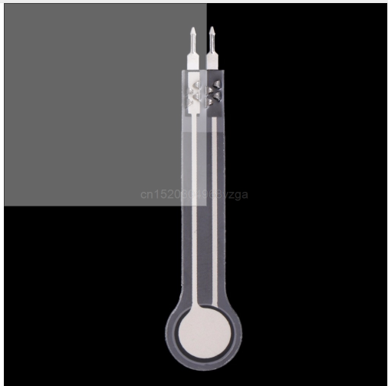

 Features:

This flexible pressure sensor is based on new nanometer pressure-sensitive materials supplemented by ultra-thin film substrate.

Highly sensitive flexible nanometer materials can realize highly sensitive detection of pressure.

It has pressure sensitive function as well as water-resistant function.

When sensor detects outside pressure, the resistance of sensor will change.

Pressure signal can be converted into a corresponding electrical signal output using simple circuit.

Specifications:

Measuring Range: 0-500g, 0-2kg, 0-5kg, 0-10kg, 0-20kg

Thickness: <0.25mm

Precision: ±2.5%(85% measuring range)

Repeatability: <±5.8(50% load)

Lifespan: >1million times

Initial Resistance: >10MΩ(no load)

Response Time: <1ms

Restore Time: <15ms

Test Voltage: DC 3.3V (typical)

EMI: Not generate

EDS: Not sensitive

Sensing Area Outer Diameter: 9mm

Sensing Area Inner Diameter: 7.5mm

Pin Spacing: 2.54mm

Quantity: 5pcs

Note: Please allow small size error due to manual measurement. Thanks for your understanding.